

##### **University of Central Punjab - Faculty of Information Technology**

# Human Computer Interaction

# Fall 2021

**PD Phase 1 (Group Work)**

**PROJECT TITLE (UCP CAFÉ APP)**

**Due Date: 03-Jan-2021**

**TOTAL MARKS = 50**

**Submission on Portal & Spiral/Tape Bind Hard copy in office.**

**__________________________________________________________**

# **Guidelines**

1. Be careful about font structure and alignment of text.
2. Late submission will cause 10% deduction per day.

# **Grading**

1. There is a strict policy against plagiarism and cheating. **The penalty can be an F grade.**
2. Your report will be judged on the following criteria. Fill in the table below:

|  |  |  |  |
| --- | --- | --- | --- |
| Group Member Roll No | Group Member Name | Sections/Sub Sections Done. | Marks Obtained |
| L1F20BSSE0558 | Ahmad Khawar | Exploratory Study, Analysis |  |
| L1F20BSSE0060 | Muneeb Khan | Problem Statement, Objectives, Analysis |  |
| L1F20BSSE0016 | Wardah Asif | Abstract, Analysis |  |
| L1F20BSSE0487 | Aqsa Tabassum | Target Market, Analysis |  |
| L1F20BSSE0080 | Syed Adeen Ashraf | Introduction, Motivations, Class Profile, Analysis |  |

____________________________________________________________________________________

***The amount of good luck coming your way depends on your willingness to act. Good Luck***

**UCP CAFÉ APP**

**Abstract**

One of the most noticeable problems we face in university café is to perceive the availability of food items and seats in cafeteria. Keeping this problem in mind, we looked up for some solution. After brainstorming, we came to conclusion with the idea of creating an application which will help everyone who’s facing the mentioned problem. Our app will allow the users to see the menu which will be updated timely by the admin according to the availability and unavailability of food. The app will show the availability of food items along with the prices. It will allow users to rate the food and give feedback. The app will display the ratings and feedbacks given by the users with the food items. This will help people in choosing the right meal. The app will also show the updated number of available seats in the café. This will save a lot of time of the users. The purpose of the app is to simplify the task of choosing the right and available meal and find seats in café for the students, teachers, guards, staff, faculty members and other related people who go through the mentioned problem. The app will be user-friendly, learnable, efficient, easy to use and time-saving. It is hoped that the app will satisfy the expectations of the users and the users will be contented.

# Introduction

We are working in a project named as UCP Café App. This app will facilitate the university students and its faculty and staff to view all of the available food or deals at the desired time. This app will also let the user know about different reviews of the user on different cafeteria food they experienced.

Also, the seats availability of the specific building cafeteria will also be given in the app so user will not find any difficulty to be seated at the cafeteria. Users also wants the fresh food, the exact timings of the food when it’s been fully cooked, will be displayed in the app with the desired food for the comfort of the user.

**1.1 Problem statement**:

The main problem faced by user is the unavailability of fresh and good quality food from the café along with limited menu and budget options.

**1.2 Objectives:**

Following are our objectives:

1: To make an application that shows all the details of UCP cafeteria.

2: To give user the leisure to select what he wants from the comfort of his location.

3: Our app should be fast.

4: Manage heavy traffic.

5: Handle errors.

6: Reliability should be maintained.

7: Bugs will be resolved.

**1.3 Motivations**:

* Large number of users
* Easy to Handle
* Team has good skills in making good interfaces of such app
* Less cost required to make this app

**Target Market Identification**

**Target Market**

People of age 18 to 60 can use this online application. Male and female both can use it. The students. Staff and faculty of university can only use and get services from this application.

**User Classes and Characteristics**

Students (use app to fulfill their need)

Faculty (use app to fulfill their need)

Management (manages the behavior of the app)

Admin (manages, check and update the app according to the availability of food and seats in the cafes)

Sweepers (use app to fulfill their need)

Guards (use app to fulfill their need)

**Primary and Secondary User Classes**

**Primary User:**

Students

Faculty

Staff

**Secondary User:**

Admin

**Justification:**

This app will change its behavior with respect to its user. Secondary and Primary Users have different characteristics and show different behaviors with respect to their needs that’s why we have to made different classes instead of have one user class.

# Exploratory Study

|  |  |  |  |  |
| --- | --- | --- | --- | --- |
| App | Restaurant from outside premises | Pre order | University café | reservation |
| Mobile ordering app for UOW | Y | Y | N | Y |
| School Café | N | N | Y | N |
| Our app | N | Y | Y | Y |

# 3.1 Requirements:

## Functional requirement

Our app will have pay with card option built into it.

Our app will have the entire cafeterias menu in the form of categories so it’s easier to navigate for the user.

Our app will allow the user to select which university cafe to order from

Our app will have the request an item option

User will also have an option to reserve a certain table if it’s available.

Our app will have the in-app wallet which will accommodate all the neglectable values (2 RS,5 RS, bigger value in case of no change)

Our app will have option to add multiple orders for a single user.

Our app will have an option to add a table number of the customer which he/she can change later even after order is given.

Our app will have deals in our app (breakfast deals, deal for 2)

Our app will have star rating for the food which is shown to the customer

Our app will have the option to pop up notifications if there is new item that we add or a new hot sale item.

Our app will allow the cafe manager to add and remove and change the price of the item.

Our app will allow the cashier to remove or add the item into the order.

Our app will allow the café manager to add the stock amount and set when to notify about restock.

## System requirements

Our system which is running the app must be connected to the internet (the user)

Our system must be able to accommodate the café manager system.

Our app will implement the rest API so that it can work on university slow Wi-Fi connection

## Nonfunctional requirements

Our app will be active 24/7 except the non-active hours of the café

Our app will have less textual button and more descriptive icon buttons for the quick learnability and memorability.

Our app will implement the easy on eyes color scheme (we can use throwaway prototype for this task)

Our app will require to sign up/login with REGNO, staff id and password.

# Usability goals

Initially we need to make sure that our user class are comfortable using the app and ordering the food and receiving the order from it thought it for evaluation we can simply hand the product in the hand of a user and just observer their behavior while they use our app. If our faculty members are able to use the app without ease then that’s’ a success because students are generally young and they understand this but old people generally find all this challenging so if they can go through the learnability and memorability then that’s a success.

# Class profiles

Following are the class profiles for the app

**Student**

**Age**: 18 to 30 years

**Gender**: 60% Male and 40% Female

**Status**: Middle class and Upper class

**Job** **Title**: Student

**Work** **Hours**: 8-12 hours per day

**Education**: Graduate and Undergraduate

**Location**: Lahore

**Disabilities**: Can be

**Family**: Single or married

**Faculty**

**Age**: 22 to 45 years

**Gender**: 50% Male and 50% Female

**Status**: Middle class and Upper class

**Job** **Title**: Professors, Registrar

**Work** **Hours**: 8-10 hours per day

**Education**: PhD, Graduate, M Phil

**Location**: Lahore

**Income**: 20000 to 3 lakh rupees

**Experience** **level**: 1-10 years

**Disabilities**: Can be

**Family**: Single or married

**Staff**

**Age**: 22 to 50 years

**Gender**: 70% Male and 30% Female

**Status**: Lower Class and Middle class

**Job** **Title**: Guards, Sweepers, Waiters, Managers, Cook

**Work** **Hours**: 8-12 hours per day

**Education**: Matric or Intermediate

**Location**: Lahore

**Income**: 20000-50000 rupees

**Experience** **level**: 0 years

**Disabilities**: no disabilities

**Family**: Single or married

**Admin**

**Age**: 22 to 40 years

**Gender**: 60% Male and 40% Female

**Status**: Middle class and Upper Class

**Job** **Title**: Managers, General Managers, Administrator, Employees

**Work** **Hours**: 8-10 hours per day

**Education**: Graduation, MBA

**Location**: Lahore

**Income**: 25000- 4 lakh rupees

**Experience** **level**: 2-4 years

**Disabilities**: no disabilities

**Family**: Single or married

* **INTERVIEW TAKEN BY AHMAD KHAWAR**

# Persona

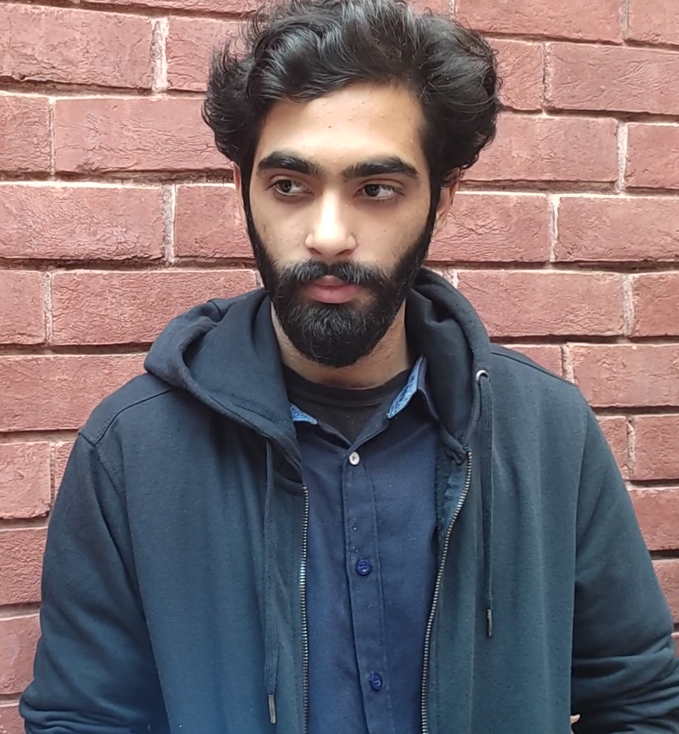

**Name: Danial**

## Who am I?

I am a university student who is studying Business to go and make my mark in the corporate world of business.

## What I do

I spend most of my day in university from morning to evening

## What’s my interest?

I spend my free time with my friends and go along with the circumstances.

## Motivation

I would use university cafeteria app in order to make up my mind for what is available in the menu and what to order

## Irritation

I need more food options and as there are less meal and more desserts

## End Goals

Know what is available, what should I order according to what’s good with ease and by avoiding hassle.

# Scenario

Danial wakes up in the morning before going to university I have my occasional breakfast my lunch time is usually spend in university as my class timings are in between. So, to have my lunch instead of actually going into café and asking the waiter about options, I take out my phone open the UCP café app and select my choice of café and start browsing through the options, I chose my options give order and my food is ready the moment I come to café.

# HTA (hierarchical task analysis)

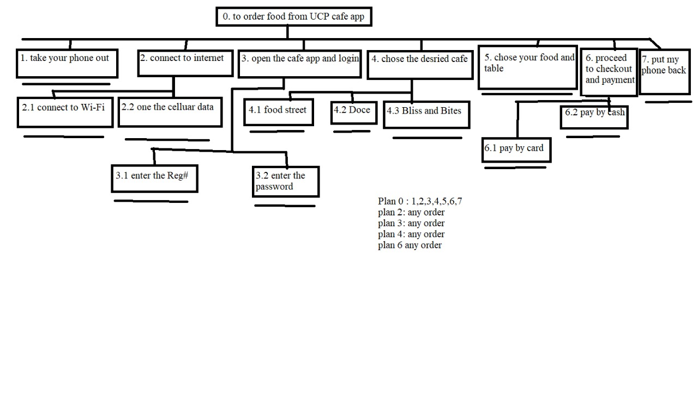

**INTERVIEW TAKEN BY MUNEEB KHAN**

***Persona:***

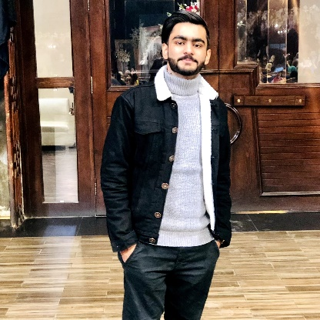

**Name:** Awais Qamar

**Professional Status:** Student

**Who am I?**

I am a student pursuing a bachelor’s degree in Software Engineering

**What I do?**

I build high risk medical software's in Pakistan.

**Interest and hobbies:**

I like to study about Artificial intelligence and related futuristic technologies. My hobbies include playing badminton and cricket.

**Irritations:**

I get irritated by slow pace and too much text and widgets.

**Motivations:**

I hope that I will get fresh and good quality food through the café app.

**Goals:**

To get fresh and good quality food from university cafeteria.

**Scenario**: Awais pick up his phone, unlocks it and tap on the UCP cafeteria app and logs in. Upon tapping, menu pops out on the screen and Awais scrolls down in search of his desired item. On arriving to his desired item. Awais hobby includes playing online action games.

He wants an app which can help him find the best and fresh food in university at the desired time. He wants to enjoy lunch with his friends and didn’t want any late and bad service at the cafeteria.

Awais selects the item and checks its freshness, quality and price. After that, he presses the add to cart option. On pressing the order button, his order is sent to processing list and his item would be delivered.

**HTA**

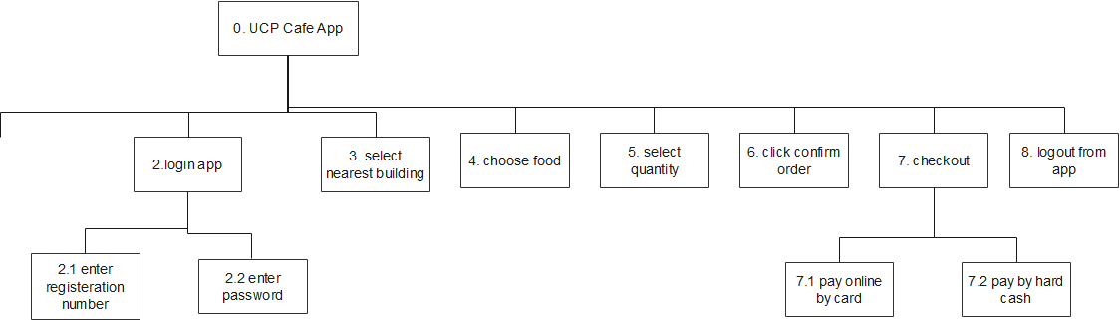

**Plan 0: 1,2,3,4,5,6,7,8**

* **INTERVIEW TAKEN BY WARDAH ASIF**

**PERSONA**

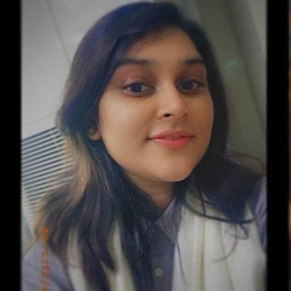

**PERSONA NAME: NAYAB AYESHA**

**Student in University of Central Punjab.**

**WHO AM I?**

I am 18 years old. I study in UCP (University of Central Punjab). I am a student of BS Software Engineering, 3rd semester.

**MY INTERESTS**

I like to hangout with my friends. My hobbies include reading and singing. I also like to travel.

**MY PERSONALITY**

I am an introvert. I talk less and observe more. I am loyal to my friends. I am a secret keeper. My friends trust me with their secrets.

**3 REASONS FOR ME TO ENGAGE WITH YOU**

* The app will save my time.
* It will help me to find suitable meal in café.
* It is a good solution of the problem I face in café.

**3 REASONS FOR ME NOT TO ENGAGE WITH YOU**

* I think it is an internet dependent app.
* I may find difficulty in using it as it is new.
* It may not work properly.

**MY SKILLS**

I am hardworking. My learning ability is very good. I have sharp memory. These qualities help me to get good grades. I am very good at sewing and stitching.

**MY DREAMS**

I want to become a skillful software engineer. I would like to work in a well-known software house. Later, I would like to get married and have a family.

**MY SOCIAL ENVIRONMENT**

I live with my parents. My mother is a house-wife. My father is a business-man. I have a small friends circle. My friends are very civilized and educated. I meet them rarely but keep in touch with them through social media.

**SCENARIO**

Nayab Ayesha is a university student. She wakes up at 7 am and sets off for university at 7:30 am. She forgets to have breakfast. She decides to eat something from university café. She goes to the café and call the waiter. She orders pasta. The waiter tells him that pasta is unavailable. She asks him what is in the menu. He tells the menu than she decides which is the suitable meal. The waiter brings the meal after half an hour. This time taking process upsets her. She decides to use the Café App next time to save her time. The app helps her a lot. She is very satisfied by the app.

**HTA:**

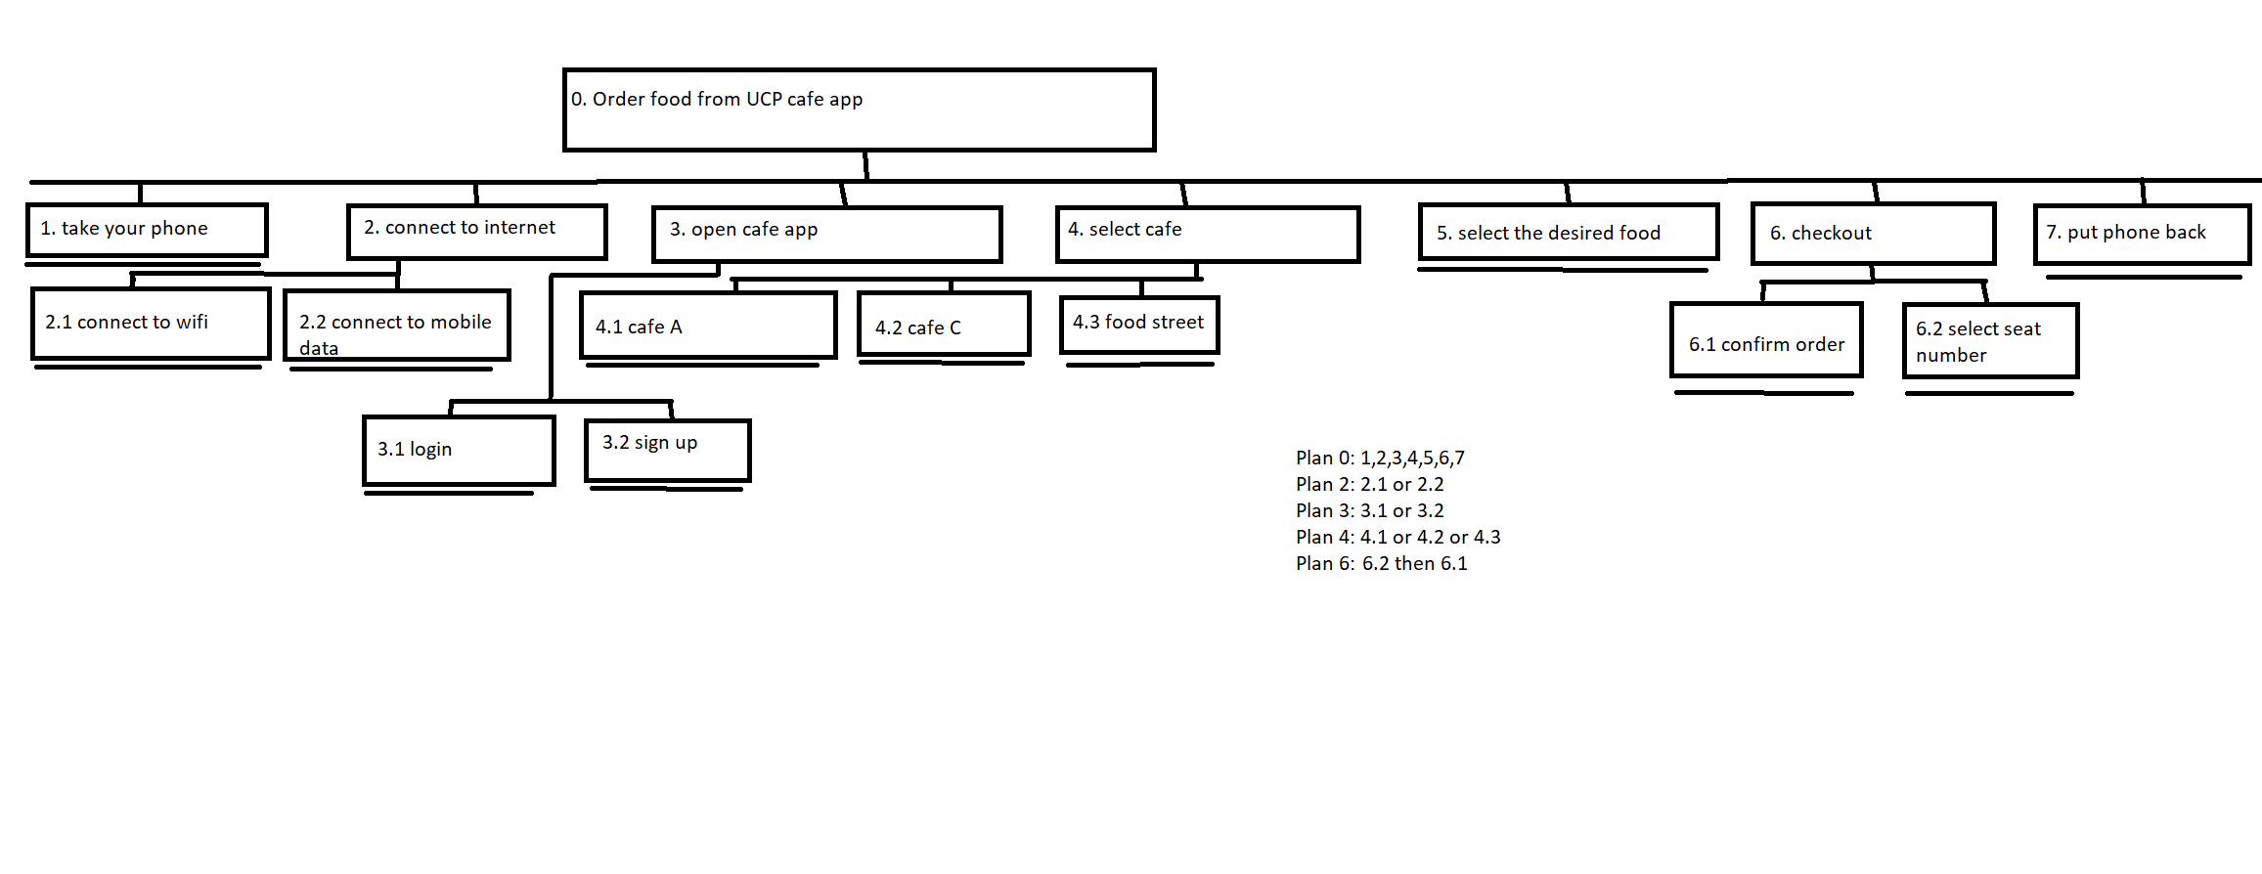

**INTERVIEW TAKEN BY AQSA TABASSUM**

**Persona**

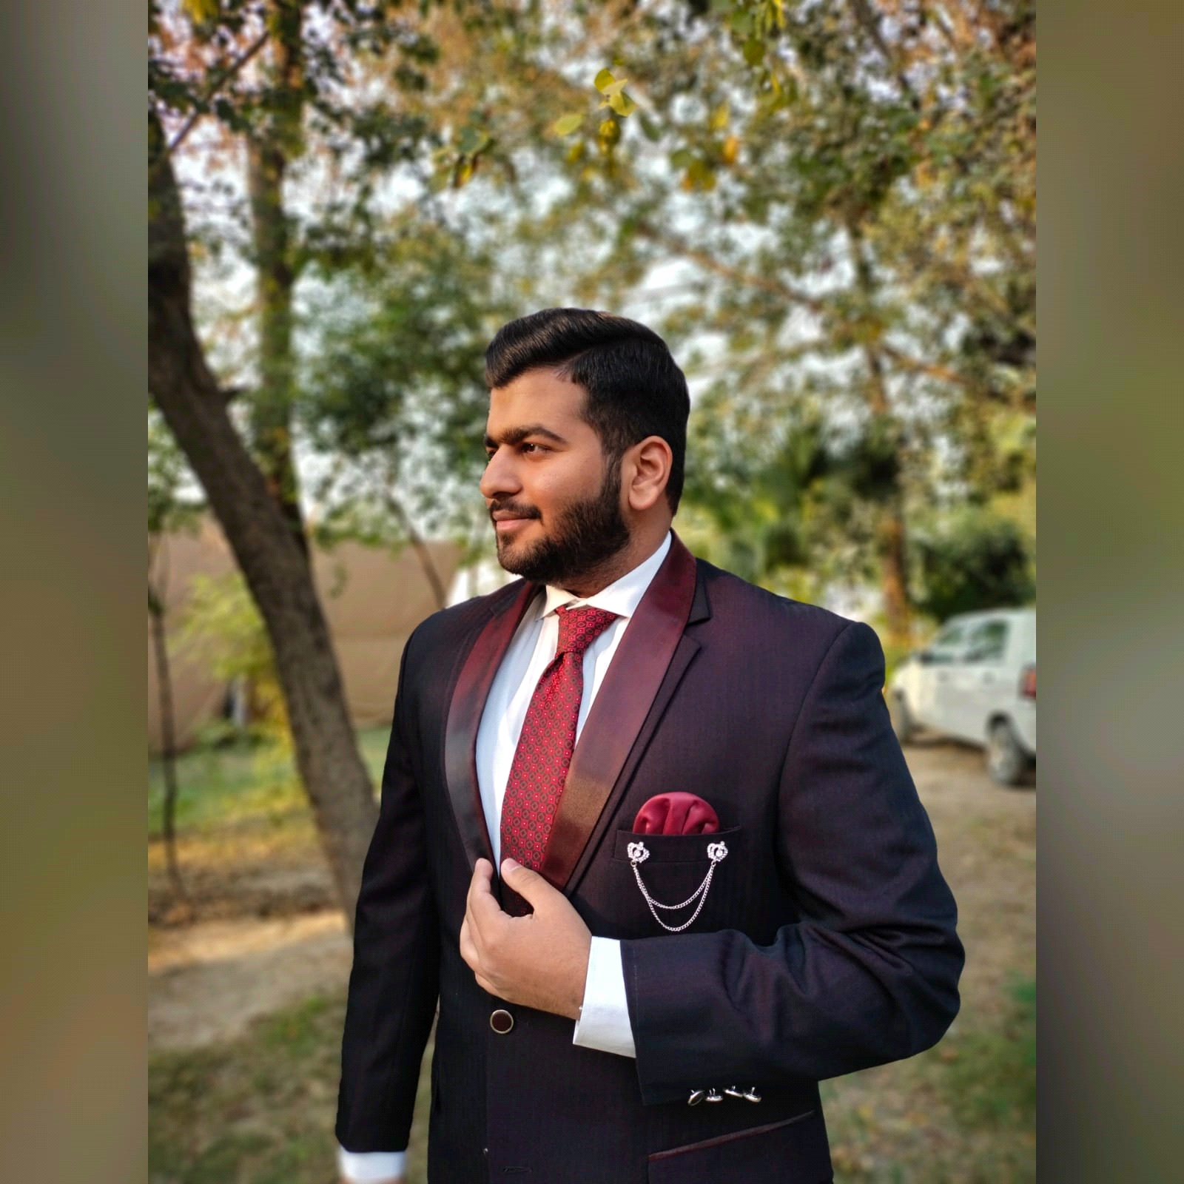

**Name :** Muneeb Nasir

**Profession:** Student at UCP

**Who Am I? (Personal Background)**

I am 21 years old. Am doing software engineering from UCP.

**What I do? (Professional Background)**

I am handling my father’s business and also doing web development. I am also a freelancer.

**Interest & Hobbies**

I am very foodie and i love to watch seasons. I use to play COD with my friends.

**Irritations**

Time wasted in finding available food in cafe and still unavailability of food . Waiting for the food order and seats to become available.

**Motivation**

This app will save most of my time and help me in finding yearning food.

**Goals**

I want a mobile application that will help me to find available food at cafe, and seats available at different cafes in university. Payment can be made through card.

**Scenario**

Muneeb is doing Software Engineering from UCP. He is also doing some extra programming languages which will help him in future. He is very foodie. But his timetable is very hectic, he just has a few minutes break in between the lectures. He has to fulfill his hunger, but there is always a huge mass in the university cafeteria.

Sometimes he could not find his desired food and the service of cafe is also becoming slow due to the crowd in it. So, he wants mobile application which will sort the problems faced by him and many others in the cafe. That app will tell him the availability of food, different deals, seats available at cafe etc. So that he will fulfill his hunger and save his time.

**HTA**

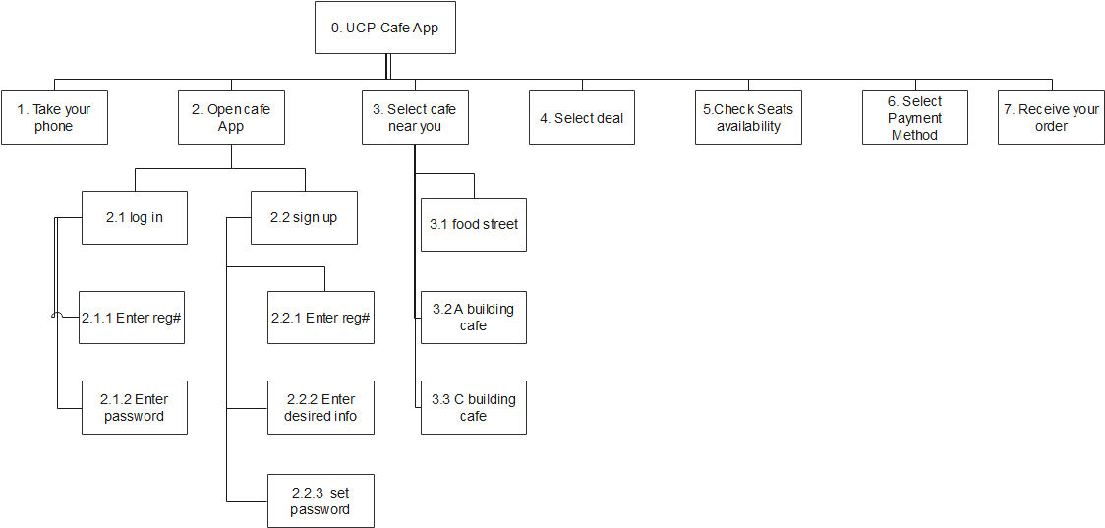

**Plan 0:** 1,2,3,4,5,6,7

**INTERVIEW TAKEN BY SYED ADEEN ASHRAF**

**Persona**

**Profile Picture:**

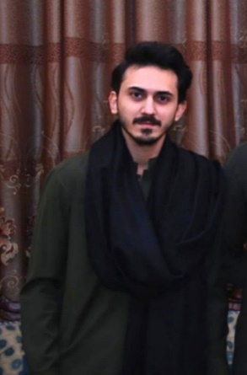

**Name:** Hamza Rathore

**Profession:** Student of UCP

**Who am I?**

I am a student of Bachelors and studying Software Engineering from University of Central Punjab.

**What I do**

I am learning different web development languages and doing internship from Webseo, which is located in Lahore.

**Interests and Hobbies**

I like reading fiction novels and my hobby includes gardening.

**Irritations**

Delay in serving times and hard cash payment.

**Motivations**

Get the deals on food which is available and know the available seating in the cafeteria.

**Goals**

I want healthy and fresh available food at university cafeteria with best and fast services.

**Scenario**

Hamza is a student of UCP and doing Bachelors in Software engineering. He is also doing internship from Webseo Software house located in Lahore. He loves to read books and plantation in his garden.

Hamza wants an app which can help him to know the available foods in the University cafeteria so that he can choose and order online. Which will help him to save his time. Also, he wanted to know the seats available in the cafe so that he can get good and fast service from the cafe and satisfy the hunger.

His goal is to save plenty of time for studies and to satisfy his hunger. He wants mobile app which can help him to get all the details of deals/food, available seating of the cafe online.

**Diagrammatic HTA**

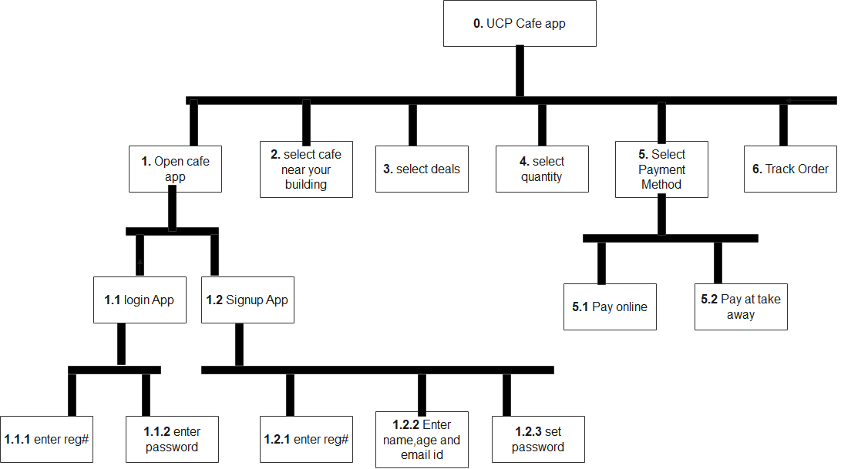

**Plan 0:** 1,2,3,4,5,6